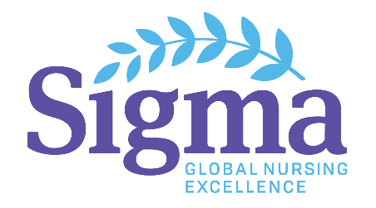 | United Nations Sustainable Development Goals Training  Western University

Report submitted by Aden Hamza, Sigma United Nations Youth Representative

In my role as United Nations (UN) Youth Representative for Sigma Theta Tau International Honor Society of Nursing (Sigma), I am always trying to find ways to share what I have learned at the UN with my fellow members and local communities. One of the main initiatives I have learned about are the Sustainable Development Goals (SDGs), which are global goals that all Member States have agreed to work toward fulfilling by 2030. These goals are interconnected and universal, meaning they are relevant and should be applied by all Member States. The SDGs were created by a global consultation with over 9 million people participating by identifying their priority areas, which culminated in the 17 goals listed here:

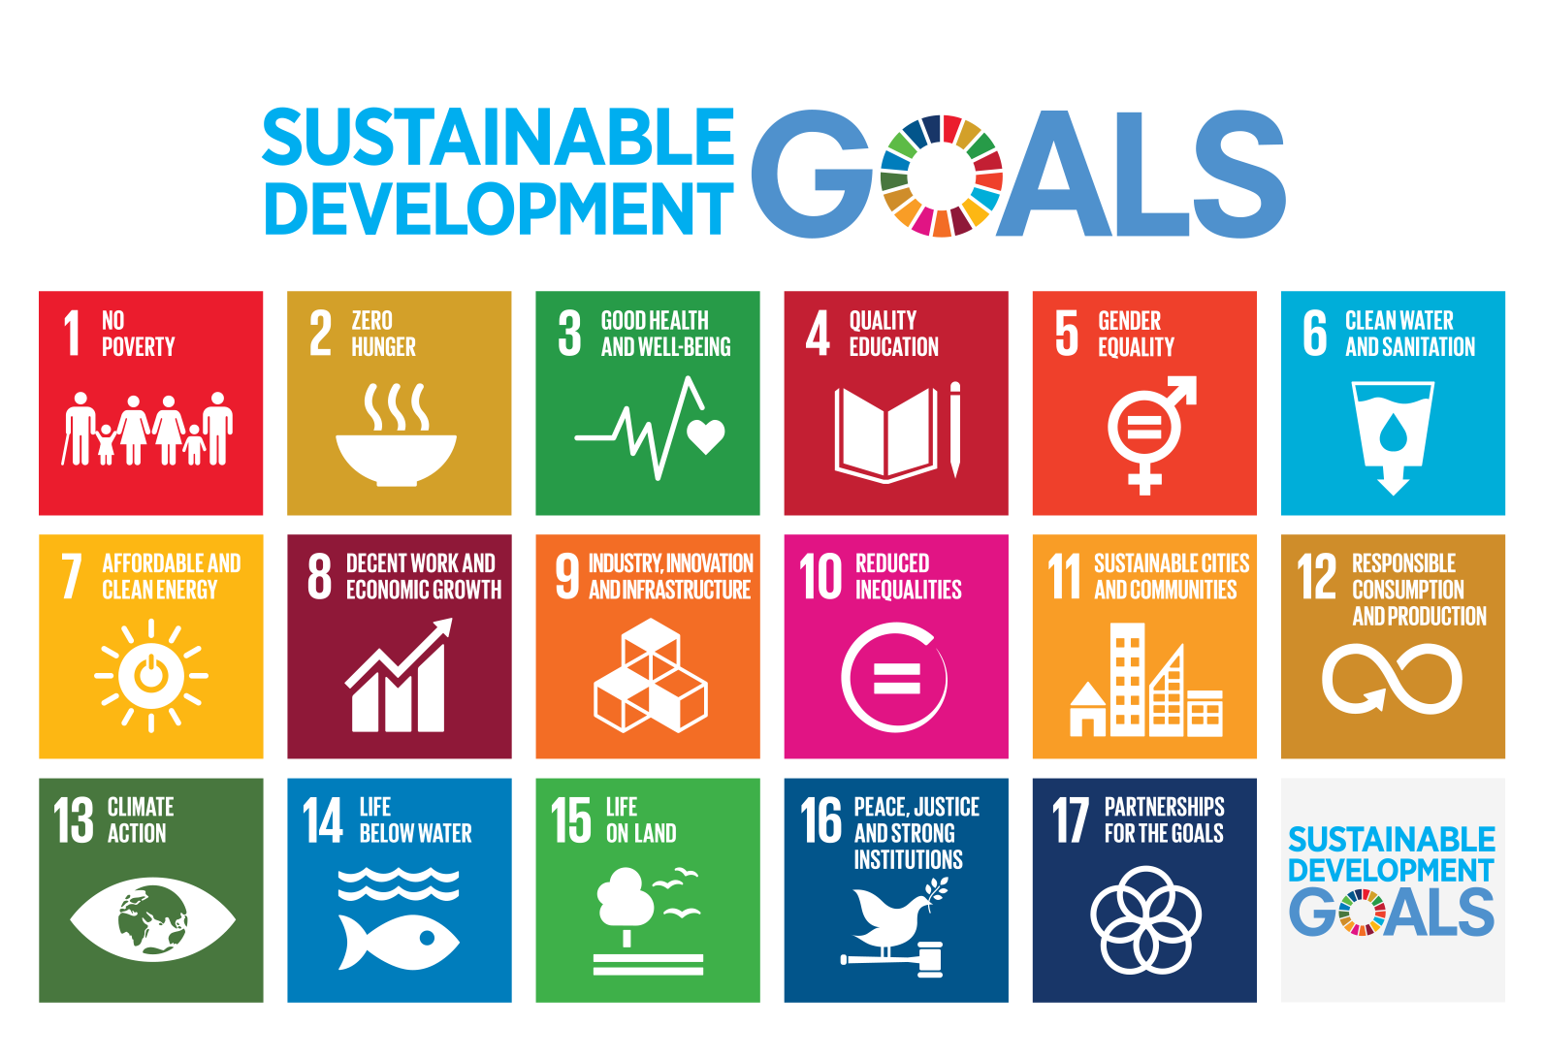
(https://sustainabledevelopment.un.org)

One of the most important steps in the first few years of the SDGs is to increase awareness within the global community, particularly the youth. As a UN Youth Representative for Sigma, I have been looking for ways to bring what I’ve learned at the UN to the students and youth in my community. I was lucky enough to meet Steve Lee, founder of the Foundation for Environmental Stewardship (FES), at a UN Women event in Toronto, Ontario, Canada, and we met again at a training session for the SDGs at the University of Toronto. We connected afterwards about the possibility for replicating this training at university campuses across the country and he brought youth together from across the country to make this happen!

The SDGs trainings took place in 50 university/college campuses across Canada (https://www.unsdgtraining.ca), and I was the lead organizer for the training at Western University, in London, Ontario, and was fully supported by Sigma’s global initiatives department. In collaboration with the Center for Environmental Sustainability and Facilities Management, as well as student clubs EnviroWestern, Western Model UN, and the University Student Council, we organized a full-day SDGs training attended by over 450 students. To open the event, we had the university’s Associate Vice-President of Finance & Facilities Lynn Logan provide greetings, as well as City Councillor Harold Usher, which helped drive home that the agenda is for our communities to achieve together. We then had the honor of having our speaker Bruce Knotts, Chair of the NGO/DPI Executive Committee, discuss the importance of the SDGs and his personal experiences and projects that led to his involvement with the United Nations. He was an incredibly inspiring speaker and we were so grateful that he stayed for the length of the conference to engage students and answer questions.
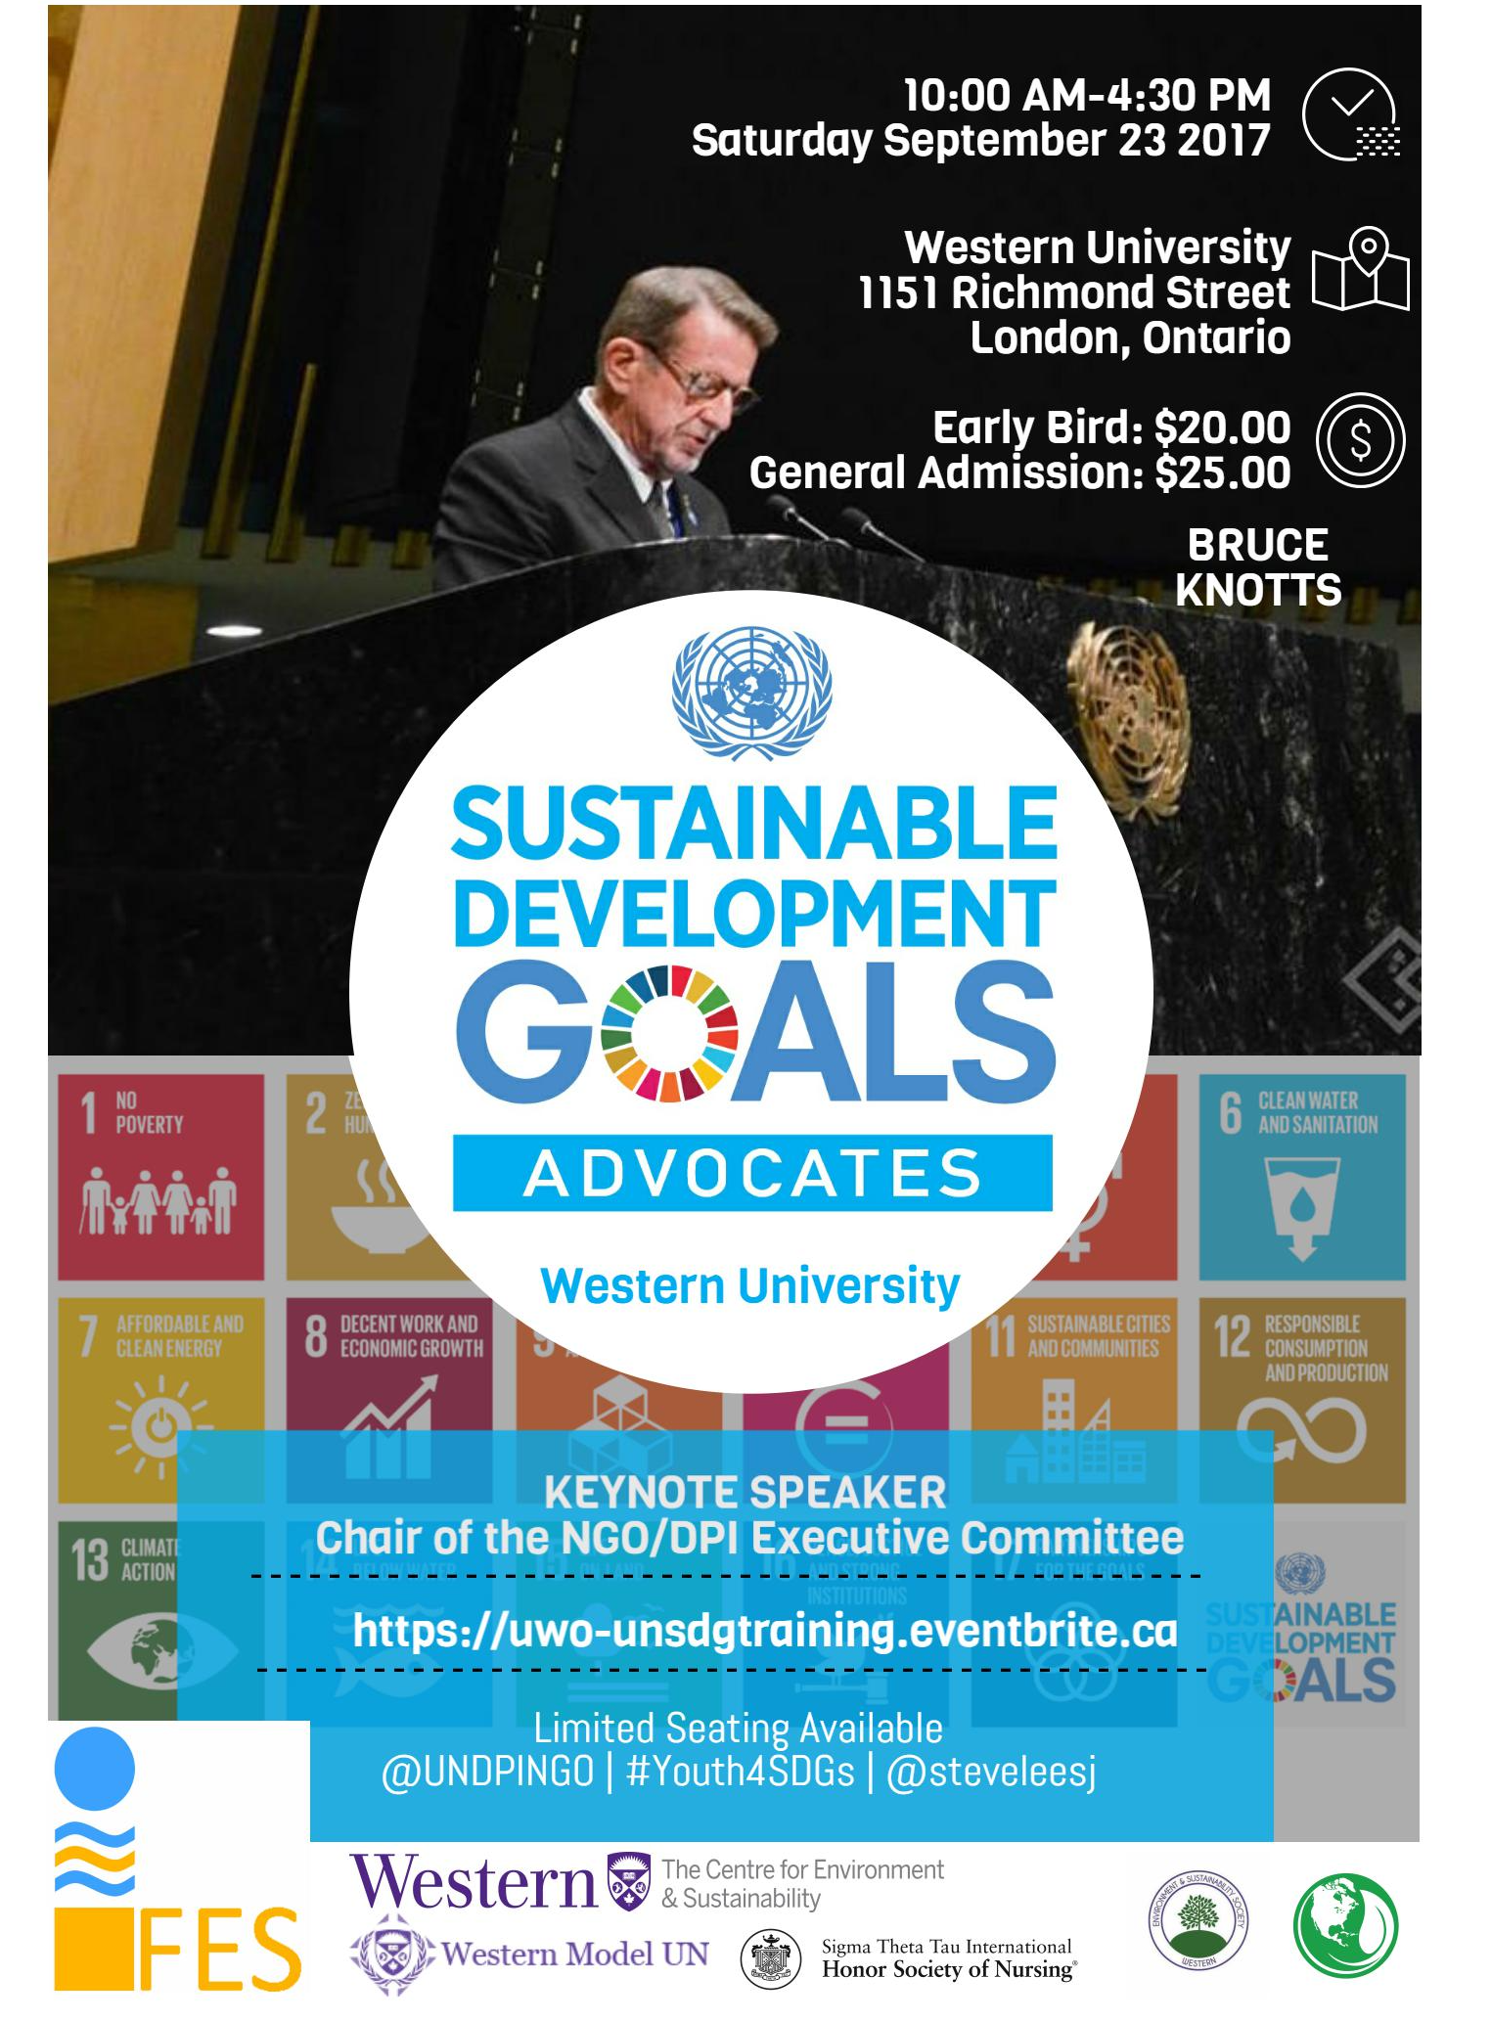

Following his presentation, students had time to network with nonprofit organizations and student clubs that work on SDG-related issues in the community, including ReForest London, Western Model UN, Habitat for Humanity, Free the Children Western, Mind Your Mind, and the Canadian Coalition for Global Health Research. The afternoon session allowed for a deeper dive into the goal of the SDGs, led by Steve Lee, and practical examples of how they have been implemented in youth-led initiatives across Canada. We also provided opportunities for local initiatives to be promoted, with Annalise Trudell from ANOVA to discuss issues of gender-based violence, consent, and the campaign to make London, Ontario, a UN Safe City, free of violence against women. In addition, Western students presented their own initiative, focused on addressing infant nutrition through innovative distribution of breast milk. Finally, a member of the Canadian Coalition of Global Health Research discussed the ways in which their organization was supporting the SDGs across the country.

Overall, the event was well received by students, organizations, and staff, and I have run into students afterwards who talk about the connections and initiatives that came from the conference. I am so grateful that Sigma supported this campaign, and helped bring the SDGs to local communities and Sigma members.

