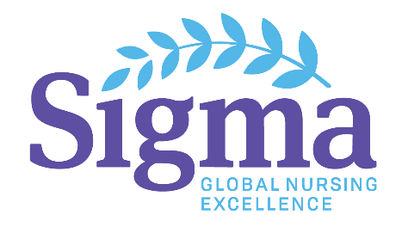
Global Regional Council
Sponsorship Funding Post-Activity Report

Per the Sponsorship Funding Application, the Global Regional Council awarded the funding must complete and submit a post-activity summary to Sigma headquarters within 60 days after the activity is completed. If no report is submitted within 60 days, funding requests will not be considered for future global regional events until such report is received.
Please submit the following information.
- Region name

- Name of event

- Overview (purpose, objectives, etc.) of event

- How did this event help fulfill the mission of Sigma, including the goals and objectives of the Global Regional Council?

- What impact will this event have on nurses who attended?

- How did chapters in your global region collaborate to plan and implement/host this event?

A summary of your event may be posted on the Global Regional Council webpage. If other regions have questions about your event, do you give permission to contact you via The Circle? ⃝ Yes ⃝ No

Your name_________________________________________________________________________________________
Chapter____________________________________________________________________________________________

