Sample Developing Honor Society Induction Script
Recommendations for Slideshow and Script:
Make sure you customize the slides and script where applicable
Add in color scheme as desired but do not use STTI purple and white
This is just a template for you, and you can add or delete as desired

1 | 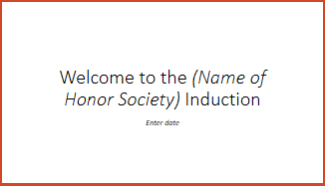 | Hello and welcome to the (name of honor society)’s member induction ceremony. My name is (honor society leader’s name) and I serve as the (position within the honor society) of the (name of the honor society).  Our officers and members are delighted that you are a part of this occasion to formally welcome you to the (name of honor society).  It is my pleasure to welcome and congratulate our inductees. We are here to celebrate your achievements.
2 | 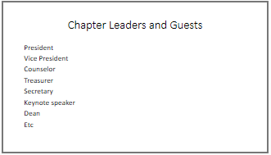 | I would like to take a moment to recognize our chapter leaders and honored guests. Please stand as I recognize you by name and position. (or have them on stage, whichever you choose to do)  President – (if not presenting)  President elect – (if applicable)  Vice President –  Counselor –  Treasurer –  Secretary –  Keynote Speaker –  Dean –  (add additional if needed)
3 | 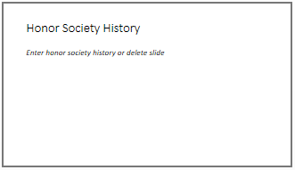 | Add in your honor society history, highlight important dates and steps taken, and create your own narrative.
4 | 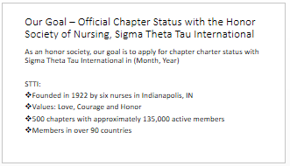 | As an honor society, our goal is to apply for official chapter charter status with the Honor Society of Nursing, Sigma Theta Tau International. STTI was founded in 1922 by six nurses in Indianapolis, IN, USA. They named the society Sigma Theta Tau based on the Greek words for Love, Courage, and Honor. STTI now has over 500 chapters, with more than 135,000 active members residing in 90 countries around the world. The mission of STTI is advancing world health and celebrating nursing excellence in scholarship, leadership, and service. As an honor society, we are following the mission and vision, bylaws, and membership eligibility criteria of STTI with the hopes of applying in (Month, Year) to become an official chapter of Sigma Theta Tau International. Pending approval of the chapter charter application, this honor society will dissolve and we will become an official chapter of STTI. We will invite each inductee/member of (Name of developing honor society) to be inducted into our new official STTI chapter.
5 | 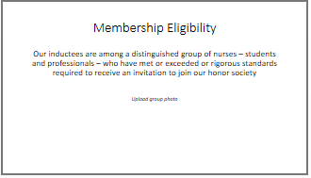 | Student members are invited to join based on their academic achievements in either a baccalaureate, masters, PhD or post-doctoral program. Nurse leaders are invited based on three criteria: being legally recognized to practice in your country, having a minimum of a baccalaureate degree in any field, and having demonstrated achievement in nursing.  All of the inductees have exceeded the rigorous standards and have demonstrated the ideal qualities of a leader and a scholar.
6 | 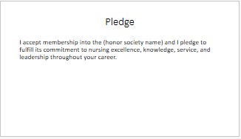 | At this time, I would ask all inductees to please rise and say the membership pledge to the (honor society name) along with me:  I accept membership into the (honor society name) and I pledge to fulfill its commitment to nursing excellence, knowledge, service, and leadership throughout my career
7 | 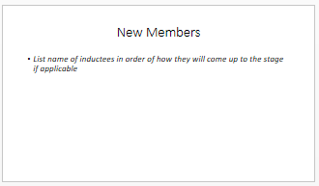 | I will now invite each of our new members onto stage to receive their member certificate and be recognized:  List candidates in alphabetical order on slide and in script
8 |  | Congratulations to the newly inducted members of (honor society name). You are now a part of a community of nursing students and leaders and we hope that you will take the opportunity to become a fully engaged member within the (honor society name).  If you do not have any further information, end here with: This concludes our ceremony, thank you all for attending. (If you have further information, use the next slide or add more as needed)
Optional—

Include name, credentials of speaker
Include title of keynote
9 | 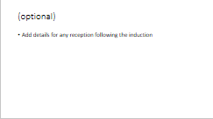 | If you have additional information about reception to follow, new member meeting, etc, add it here.  End with: This concludes our ceremony, thank you all for attending.

