Preparing for and Conducting an Induction Ceremony

Time: The induction ceremony may precede a reception, luncheon or banquet.

Dress: Members and inductees professional, street attire, or evening dress are predetermined by the chapter.

Induction Ceremony Script and Slides
There is a sample script and slides available on the website. Developing honor societies (DHS) should customize these templates in order to be culturally relevant to its inductees. Typically, it is the DHS president that presides over the ceremony, however the group may make changes as are appropriate. Scripts and slides should be edited to accommodate any distinguished guests to be recognized.

Induction Certificate Preparation
Membership certificates and several other induction ceremony materials may be printed by the DHS before the ceremony. The DHS may also choose to purchase certificate holders. If so, be sure to put the certificates in the holders in the days prior to the ceremony. Be sure to check on the day of the ceremony that no new inductees have RSVP’d and paid, and print additional certificates as needed.

Groups may also wish to have some extra, blank certificates to present to inductees who arrive at the ceremony without having RSVP’d, so they may still participate.

Recommended Ceremony Materials
Items include:
- Minimum of one 8ft. long table (for large inductions, multiple tables may be needed)
- Cloth table covering – white, black, or DHS colors (should not use purple & white)
- Signature book and pens for inductee signatures
- Induction certificates and certificate holders (to be purchased/printed by the DHS)
  - Place certificates in the provided holders prior to the ceremony
- Flowers, pins, or honor cords (if desired by the DHS)
- Induction ceremony script should be placed on the podium
- Projector or presentation equipment if using ceremony slides

OPTIONAL items include:
- Candles or candelabras
- Flower arrangement
- Corsages and/or boutonnieres for the dean(s) of the nursing program, DHS president/leaders, and/or special guests

Stage Preparation
  - Set-up of the ceremony venue should be completed at least 2 hours prior to the ceremony start time.
  - Ensure that the stage is large enough for the participants to move about
  - The flow of traffic should be left to right when facing the stage
  - All presiders, presenters, and DHS leaders involved should be seated on the stage, or in the front row
  - Electric cords should be covered with tape to avoid the possibility of tripping
  - Certificates should be arranged in order of presentation (alphabetical order recommended)
  - Seats directly in front of, or beside, the stage should be reserved for inductees
- Seat inductees in order in which they will be called (alphabetical order recommended)
- Plan to have a brief “run through”/rehearsal for all presiders and DHS leaders involved in the ceremony

- Materials for Guests
- Produce an Induction Program
- This can include information about the goal of the DHS to apply to become a chapter of STTI. Information about STTI can be included, but it should be clear that the DHS is not yet affiliated with STTI, and not yet a chapter.

Conducting the Ceremony
- Inductees should be greeted and asked to check-in upon arrival
  - This allows the DHS the option to add or delete inductee names, or add an “Absentee” slide to the presentation and script before the ceremony begins
- Volunteers should be on-hand to show inductees to their assigned seats
- As each inductee’s name is called, they come forward to be inducted
- A designated DHS leader presents the membership certificate
- A designated DHS leader presents the flower, or honor cords, if applicable
- Each inductee signs the signature book prior to exiting the stage
- After the new members have been inducted into the DHS, all members extend congratulations to the new members

Remember, these are only guidelines. Room dimensions and DHS leaders’ creativity can alter these outlined suggestions to better meet the needs of the chapter and its members.

Sample Stage Set-Up and Flow
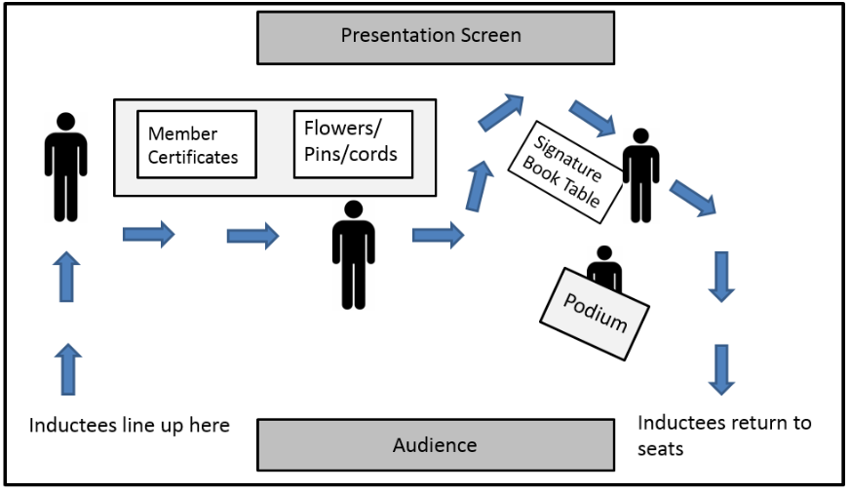
Within this sample, a smaller second table is used to hold the signature book to prevent inductees from turning their backs to the audience.


