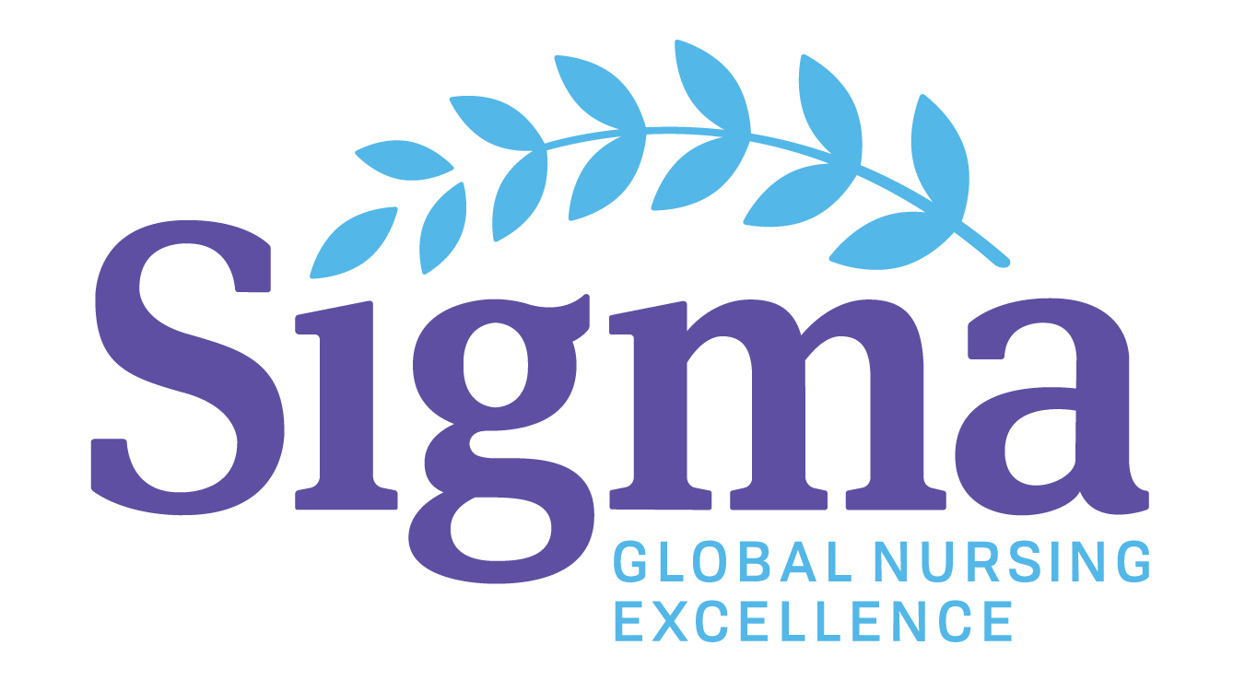

Title: Youth Representative

Job Summary: A Sigma Theta Tau International (Sigma) youth representative represents Sigma to the United Nations Department of Public Information (DPI) and the non-government organization (NGO) community. They attend and/or participate in various United Nations (UN) events/programs/activities, related to health, nursing, or other areas of interest to Sigma, with the purpose of gathering information to inform and advise the Sigma Global Initiatives department to fulfill Sigma’s mission. This role reports directly to the Global Program Manager in the Global Initiatives department.

Principal Responsibilities of Youth Representative
- Attend a minimum of four (4) on-site and two (2) virtual, health, nursing, or other areas of interest to Sigma, United Nations briefings, special sessions or meetings
- Participate in, and stimulate dialogue and conversation within, the Sigma community regarding UN programs, goals and activities
- Participate as available in Sigma sponsored UN activities and presentations
- Document and communicate the UN experience to the Global Initiatives department, for dissemination to our chapters, members and regions
- Participate in a ½ day meeting regarding your role and responsibility as a Sigma youth representative presented by Sigma
- Attend an orientation sponsored by the UN to learn about the UN and what it means to be a youth representative
- Engage with other Sigma youth representatives and the Global Initiatives department to coordinate Sigma UN presence
- Participate in regular conference calls with the Global Initiatives department
Minimum Requirements
- Have knowledge of Sigma’s global initiatives.
- Ability to travel to attend UN events in New York, NY, United States
- Be between the ages of 18 and 28 at time of application
- Be an active Sigma member throughout the term of service
- Serve a two-year term during the duration of Sigma’s biennium. By invitation, option of applying to renew for a second, two-year term
- May not hold another position at the regional/global level with Sigma while in the role of UN youth representative
- Submit Activity Reports and receipts for reimbursement within one month of activity.
Principal Responsibilities of STTI
- Engage youth representative participation in Sigma sponsored activities and presentations affiliated with the UN
- Apply for and assign an annual or temporary UN grounds pass which allows access to UN headquarters in New York, NY, United States
- Coordinate regular conference calls with Sigma representatives
- Promote and disseminate the work of the Sigma UN youth representatives to Sigma members and other interested audiences
- Feature the Sigma UN youth representatives on the Sigma Global Initiatives department website
- Provide supplemental reimbursement for travel and food expenses upon submission of receipts and Activity Reports, up to a maximum of US $100 per month (through June 2018)

