Recommendations for Induction Presider:
- Please review slide 27. Either remove it before the induction or fill in the slide with after-induction event information.
- Prepare a one- to two-minute personal testimonial for slide 17
- Seat candidates in alphabetical order at the front of the room.

1 |  | Good morning/afternoon/evening, my name is  [Name and Title]. I would like to welcome you all to the Honor Society of Nursing, Sigma Theta Tau International [Chapter Name] Chapter charter amendment and induction ceremony. I am delighted you are here to celebrate this special occasion with us.
2 | 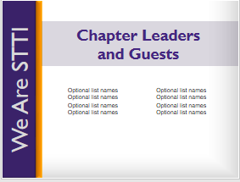 | I would like to take a moment to introduce our chapter leadership and other invited guests who are with us this morning/afternoon/evening.  [Introduce those in attendance by name and title.]
3 |  | Let’s begin our chapter charter amendment ceremony and induction. For more than 90 years, Sigma Theta Tau International — or STTI — has been recognizing and celebrating nursing excellence in scholarship, leadership, and service.  [Chapter Name] chapter at [University] is proud to add [School Name] to our charter as a member this global community of nursing.
4 | 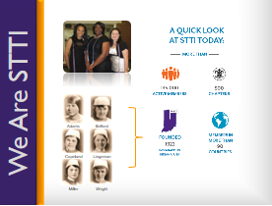 | The Honor Society was founded in 1922 by six nursing students at Indiana University [in the United States of America]. From those six founding members, our organization has grown to more than 135,000 active members in over 90 countries around the world. Our organization has more than 500 chapters worldwide.  STTI also collaborates with several global organizations to improve the health of the world’s people, including representation at the United Nations. This offers members the opportunity to extend their reach outside of their own communities.  We are excited and filled with pride to welcome our newest chapter and inductees here today into our diverse and global membership.
5 | 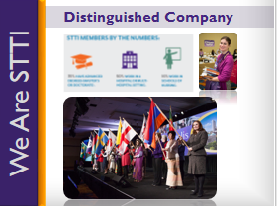 | [Address remarks directly to inductees]  STTI members are leaders at all levels of the healthcare industry. STTI only extends membership to students in baccalaureate or graduate level programs who have demonstrated superior academic achievements, academic integrity, and professional leadership potential and to nurse leader candidates exhibiting exceptional achievements in nursing. Our membership includes top-notch nursing and midwifery executives, clinicians, educators, researchers, policymakers, entrepreneurs, and others.  You are among this distinguished group of nurses — students and professionals — who have met or exceeded the rigorous standards required to receive an invitation to join STTI, and you truly deserve our congratulations.  [Presider leads applause]
6 |  | The leadership and scholarship that you have displayed represent the essence of the society.  You are Sigma Theta Tau; We are Sigma Theta Tau.
7 | 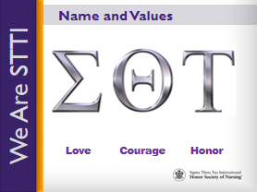 | Sigma.  Theta.  Tau.  Taken from the Greek words meaning Love, Courage, and Honor, these are the Greek letters chosen by our founders to be the Honor Society’s name, as they believed them to be the enduring values that are the root of the nursing profession.
8 | 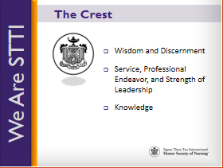 | Our crest, which adorns your membership certificate, symbolizes these enduring values, reminding us of our commitment to:  - Wisdom and discernment, as represented by the eye;  - Service, professional endeavor, and strength of leadership, as represented by the pillars of stone at the right and left; and  - Knowledge, as represented by the lamp.
9 | 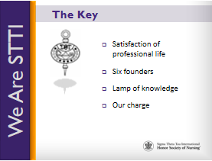 | Our key, embedded in the membership pin, reminds us of our charge to uphold love, courage, and honor and is a symbol of scholarship.  - The cup denotes the satisfaction of professional life;  - The circle with its six stars represents our six founders;  - The lamp is the lamp of knowledge; and  - The letters in black represent our charge.  Remember that our key symbolizes your commitment to nursing excellence.
10 | 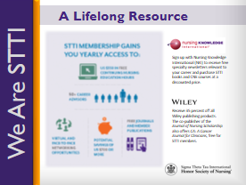 | The purpose of this ceremony is not only to honor you as a new member and celebrate your successes, but it also serves as our pledge to you to support you throughout your nursing career and to be a lifelong resource for you.  This support will come, in part, through the opportunity to participate in STTI’s communities of interest, mentoring programs, and academies. You will also have access to benefits such as continuing nursing education courses, the Journal of Nursing Scholarship, Worldviews on Evidence-Based Nursing, and Reflections of Nursing Leadership.
11 | 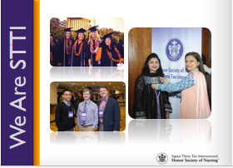 | Your induction is not the end – the culmination of your scholarly or professional achievements; instead, your induction signifies the beginning of your membership journey – the start of your involvement within a global network of peers and mentors who are here to guide and support you wherever your nursing career may take you.
12 | 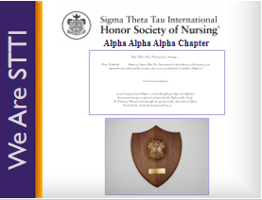 | [Presentation and Response]  Charter Amendment Officer:  Because you have demonstrated your commitment to nursing excellence, met the requirements for amending a chapter charter, and were approved by STTI, I am pleased to amend your chapter’s charter to include more schools of nursing.  Will the following representatives please come forward:  (name and title), at _______________ (college/university name for each school being added to the chapter’s charter)  (name), president of the _______ (chapter name) Chapter.  As representatives from your schools, do you know and accept the purposes of the Honor Society of Nursing, Sigma Theta Tau International?  Representative from College/University(s) to be Added:  Yes, we have studied the purposes of the Honor Society of Nursing, Sigma Theta Tau International, and we accept them as the model for our own endeavors.  Chapter President:  On behalf of the members and prospective members, I pledge our at-large chapter’s commitment to the purposes of Sigma Theta Tau International.  Charter Amendment Officer:  On the recommendation of the Honor Society of Nursing, Sigma Theta Tau International Board of Directors, and by the power vested in me as the chartering officer, I am pleased to announce the inclusion of this (these) additional school(s) of nursing in the ______________ (Greek name) at-Large Chapter, chapter number (fill in chapter number) of Sigma Theta Tau International.  [Pause for applause]  First, I present to you a replica of the top portion of the charter. Following this ceremony, the new school(s) of nursing joining the chapter will receive a charter with the members’ names inducted today inscribed on it to supplement the chapter’s original charter.  Second, I present a coat-of-arms plaque for the new school(s) of nursing joining the chapter. This plaque symbolizes the ideals of STTI and is inscribed with your chapter’s name, your school name, and the charter amendment date. Your school may choose to display the charter and coat-of-arms as a symbol of its continued commitment to nursing excellence and STTI’s purposes.  Chapter President:  On behalf of the current and prospective members, I am honored to accept this amended charter and coat-of-arms plaque for the (Greek name) at-Large Chapter at (college/university name) and (college/university name). We are proud to become an at-large chapter and pledge our commitment to nursing excellence and STTI’s purposes.  [Pause for applause]  [Representatives may return to their seats]  Charter Amendment Officer:  Will (name), (position title—head of school/dean/director of each new school now involved with the chapter), and _________ (name), (position title—dean or director of each existing school involved with the chapter), please come forward to congratulate the at-Large Chapter for receipt of its amended charter and coat-of-arms.  [Dean/Director should present a congratulations message from the nursing school or college/university. Dean/Director should also allow brief congratulatory messages from others. Dean/Director should then return to his/her seat.]  Charter Amendment Officer:  Thank you, (dean/director’s name) and (dean/director’s name). Please join me in congratulating this new at-large chapter of the Honor Society of Nursing, Sigma Theta Tau International.
13 | 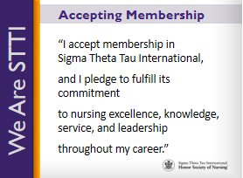 | At this time, we will receive into membership these outstanding new members. Inductees, please stand.  [Pause]  Please accept the privileges and responsibilities of membership in the Honor Society of Nursing, Sigma Theta Tau International by repeating after me.  I accept membership in Sigma Theta Tau International [pause]  and I pledge to fulfill its commitment [pause]  to nursing excellence, knowledge, service, and leadership [pause]  throughout my career.  Inductees, please be seated.
14 | 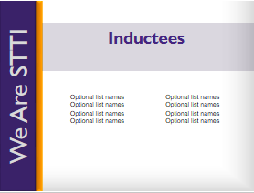 | [The charter amendment officer should now join other chapter leaders on the stage to shake hands with the new inductees as they come on stage to receive their new member materials. Only those nurses who are new members to STTI will receive a membership card, certificate and materials.  Chapter president should first recognize any deans, heads of school, or officers from the new school(s) to be added to the chapter first. These people should be called up first to receive the new member materials. If these people are already members of STTI, the president does not need to call these people up on stage.]  Chapter President:  Helping us congratulate and recognize __________________ (chapter’s name) new members are: (introduce people on stage)  __________________(name) ____________________ (title)  __________________(name) ____________________ (title)  __________________ (name) ____________________ (title)  __________________ (name) ____________________ (title)  New members, please come forward when your name is called to receive your certificate and sign your name in the [Chapter Name] record of membership.  [Insert candidates’ names here.]  [President will call each candidate forward.  In a line:  - The chartering officer will present certificate to and shake hands with each candidate.  - Chapter officers will:  - Pin purple ribbons on candidates  - Distribute other membership materials  - Distribute flowers (optional)  - Assist with the Signature Book]
15 | 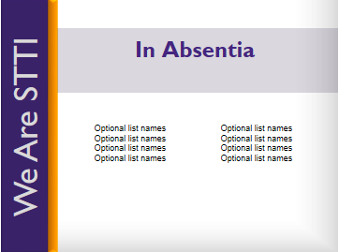 | Chapter President:  We would also like to recognize our new members who were unable to attend today’s ceremony. We welcome them as well and hope they can join us at our next gathering.
16 | 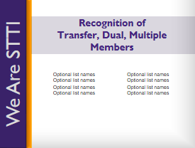 | Chapter President:  I would like to take a moment to recognize STTI members who have transferred to this new chapter or have become a dual or multiple member. Along with our newly inducted, these members will also be considered chartering members of ______ (name of chapter). Please stand and be recognized.
17 |  | Chartering Officer:  Please help me congratulate these Sigma Theta Tau International members with our applause.  [Presider leads applause]  Now that you are official members of STTI, the opportunities to become involved, to grow and develop as leaders, and to contribute to the nursing profession are virtually endless. Personally, I have enjoyed being actively involved by [insert personal testimonial].
18 |  | Each of you will experience membership in your own way. In fact, STTI membership is an experience that is yours to design. I hope you will make use of the many opportunities that membership has to offer. Not only do you have the opportunity to be involved locally, but there are opportunities to participate in this global organization on a regional and international level as well.
19 |  | Each biennium, STTI installs a new president at the international level. This biennium, we proudly installed Dr. Cathy Catrambone and introduced her as the 31st president of Sigma Theta Tau International.  Each president presents a Call to Action to help guide members and chapters as we strive to fulfill our mission. President Catrambone’s call asks us to Influence Advance Global Health and Nursing through advocacy, policy, lifelong learning, and philanthropy.
20 |  | Advocacy is the act or process of pleading for, supporting, or recommending a cause or course of action. Advocacy is a central element in nursing and midwifery. From the moment we enter the profession, we advocate for patients; we “give voice” to what is needed to promote the safety and well-being of those we serve. We advocate for individuals, communities, and populations. We advocate for rights, causes, and issues. We possess the knowledge, skills, relationships, and the passion to be effective advocates. Now is the time to embrace advocacy, to amplify our voice, to bring together stakeholders, and to exert influence to achieve the changes needed in healthcare.
21 |  | We are also called upon to bring together communities and stakeholders to collaborate on policy discussion and action. We bring credibility to the message and influence decision makers. We are challenged to influence and advance in policy in the areas where we live and practice. Embrace opportunities to create, influence, evaluate, and change health policy within your practice environment, professional organizations, health associations, and community. Develop relationships with local legislators, ministers of health, and administrators. Leverage professional networks and social media to share important changes being made in the policy arena.
22 | 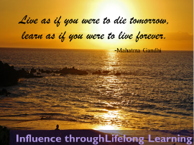 | Advance through lifelong learning. This charge urges each of us to engage in lifelong learning by pursuing advanced education and certifications, and by taking advantage of STTI knowledge products and services.
23 |  | The last charge presented to us is one of philanthropy, which means giving of your time and talent in addition to monetary support. Consider performing 90 minutes of service in honor of STTI Founders Day on 5 October each year. Volunteer. Support STTI’s Future, Leadership, and Research funds, and advocate for the STTI mission.  I would encourage you all to learn more and participate in fulfilling President Catrambone’s Call to Action by visiting STTI’s website, nursingsociety.org.
24 |  | I want to take a moment to recognize and thank the friends and family who are here to celebrate this special occasion with us. It is because of your love and support that these new members were able to reach this level of success, and you should take pride in the role you have played.
25 |  | As we conclude our ceremony, I want to once again congratulate and welcome our newest members of Sigma Theta Tau International.  [Lead applause]  Thank you for attending. Have a wonderful day/evening.
26 | Optional | Optional Slide  [If the group is having a reception, dinner, or refreshments after the ceremony, include information here]

